[https://trello.com/b/tu1nUusR/scrumboard-sprint-3  
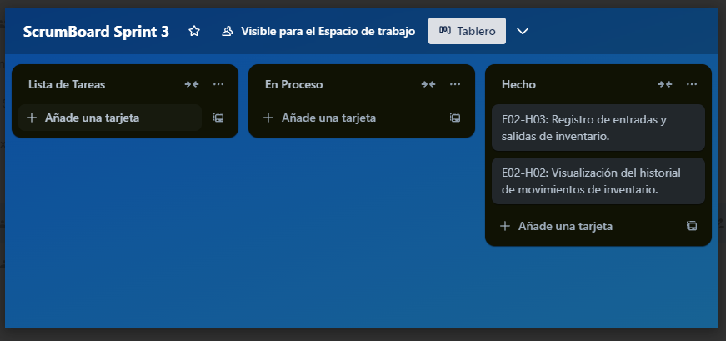](https://trello.com/b/tu1nUusR/scrumboard-sprint-3)